**DATABASE DESIGN**

**ADMIN:**

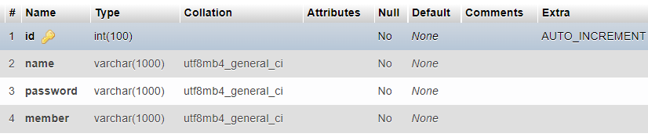

**CART:**

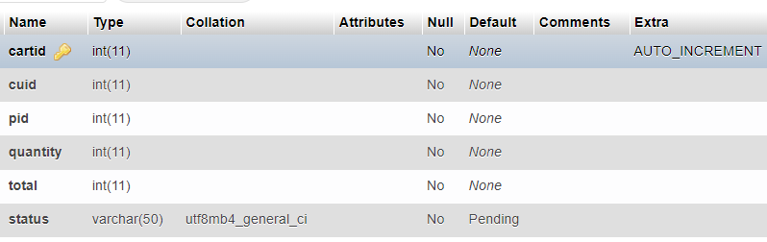

**CATEGORY**

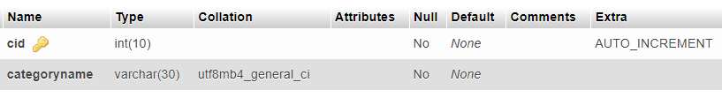

**CUSTOMER:**

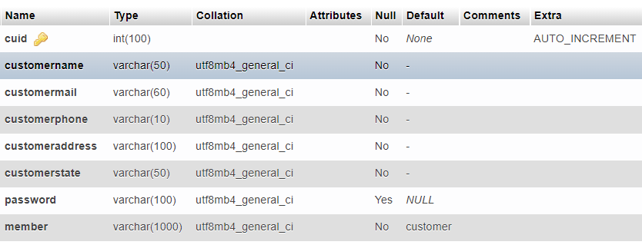

**DISEASE**

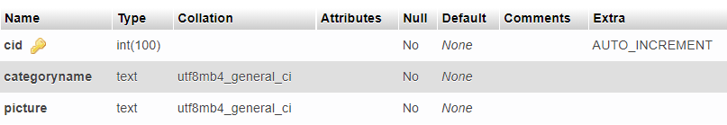

**CUSTOMER:**

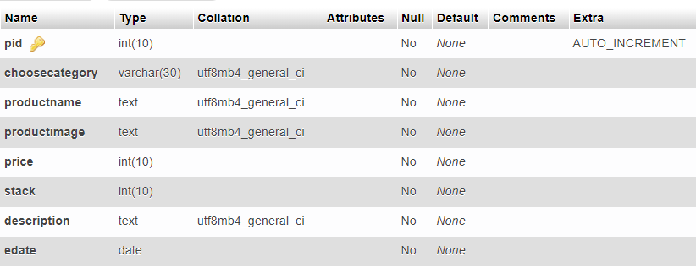

**SM (HEALTHCARE PROVIDER VIDEO):**

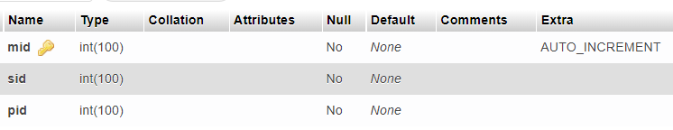

**SV(HEALTHCARE PROVIDER MEDICINE):**

